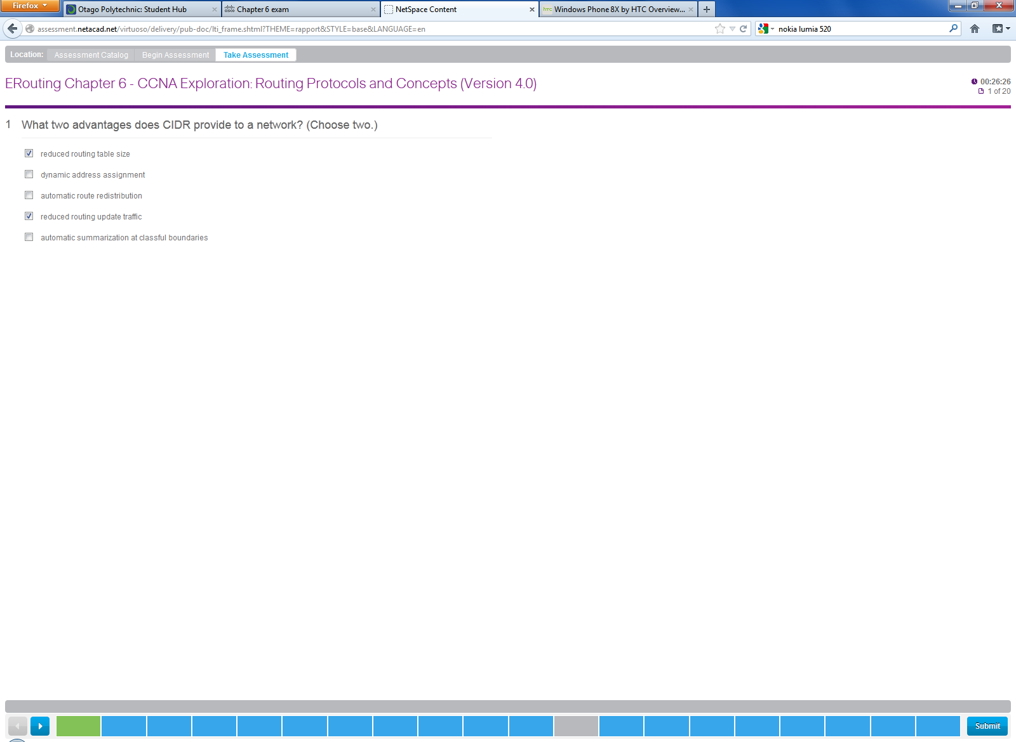

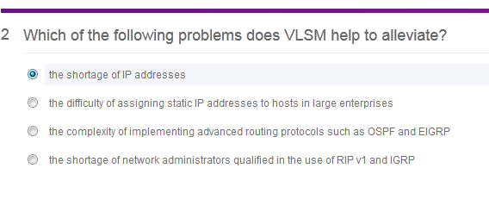

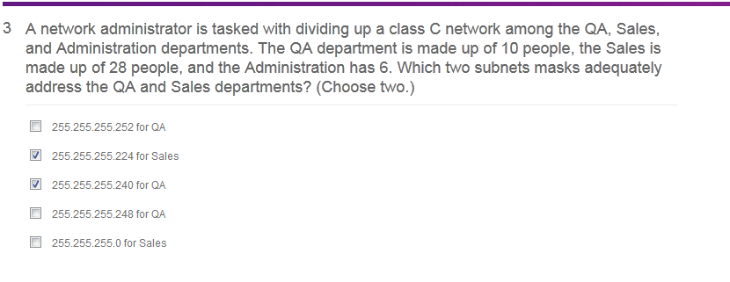

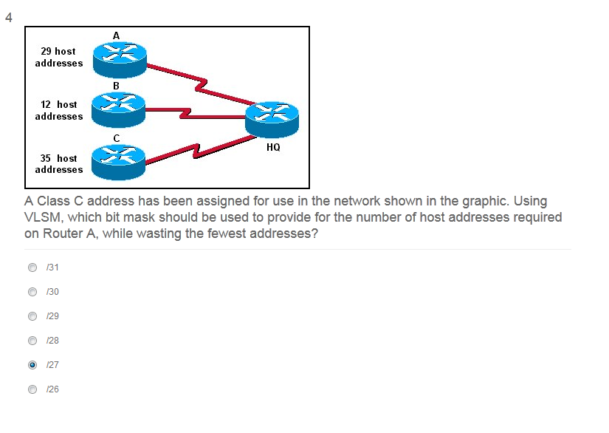

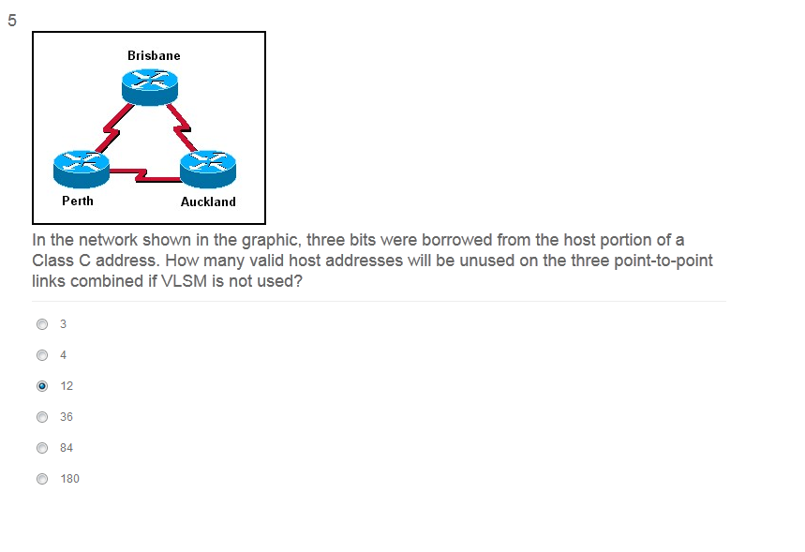

**3**.

[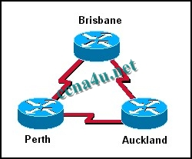](http://answers.ccna4u.net/wp-content/uploads/2011/02/116.jpg)

**In the network shown in the graphic, three bits were borrowed from the host portion of a Class C address. How many valid host addresses will be unused on the three point-to-point links combined if VLSM is not used?**  
3  
4  
12  
36  
84  
180

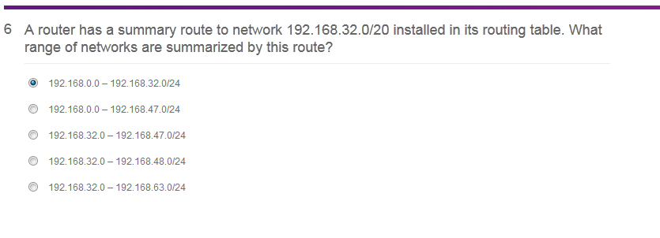

**19**. **A router has a summary route to network 192.168.32.0/20 installed in its routing table. What range of networks are summarized by this route?**  
192.168.0.0 – 192.168.32.0/24  
192.168.0.0 – 192.168.47.0/24  
192.168.32.0 – 192.168.47.0/24  
192.168.32.0 – 192.168.48.0/24  
192.168.32.0 – 192.168.63.0/24

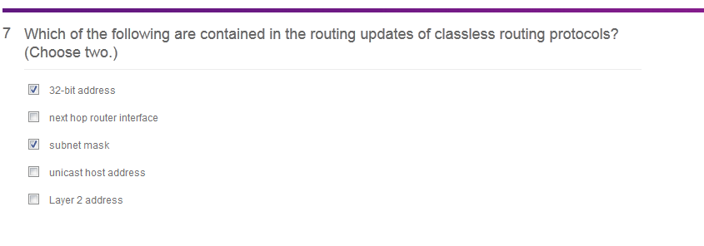

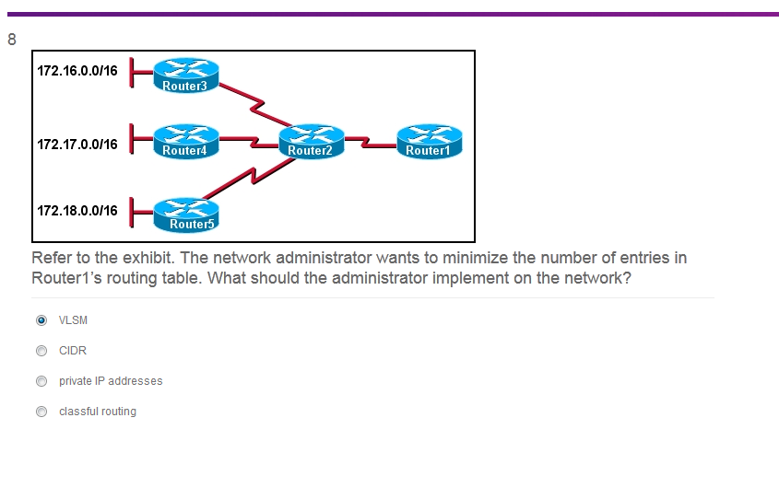

**20**.

[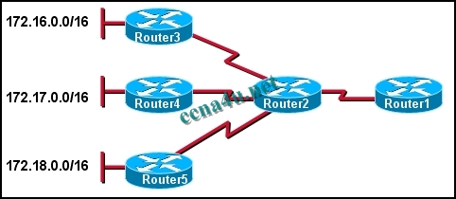](http://answers.ccna4u.net/wp-content/uploads/2011/02/083.jpg)

**Refer to the exhibit. The network administrator wants to minimize the number of entries in Router1’s routing table. What should the administrator implement on the network?**  
VLSM  
CIDR  
private IP addresses  
classful routing

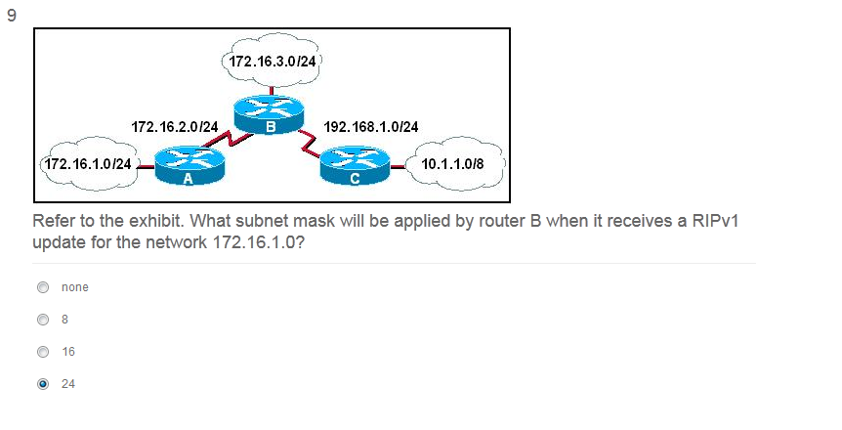

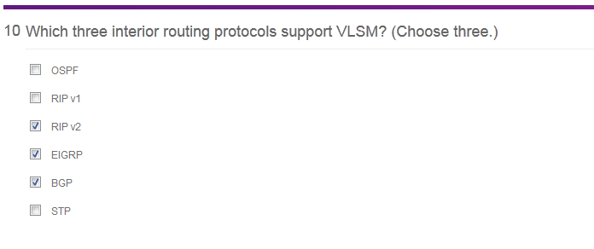

**7**. **Which three interior routing protocols support VLSM? (Choose three.)**  
OSPF  
RIP v1  
RIP v2  
EIGRP  
BGP  
STP

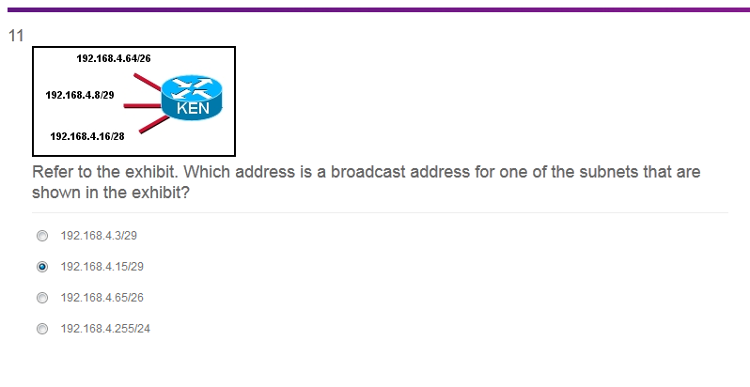

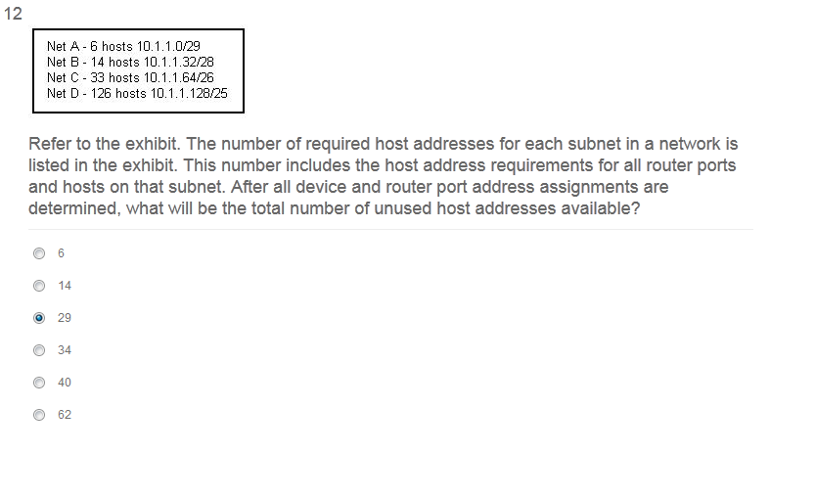

I didn’t have an answer for this one

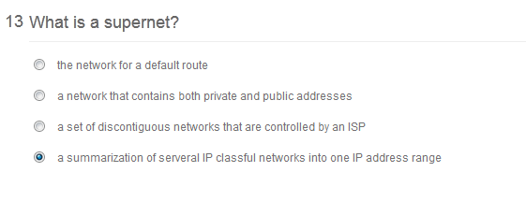

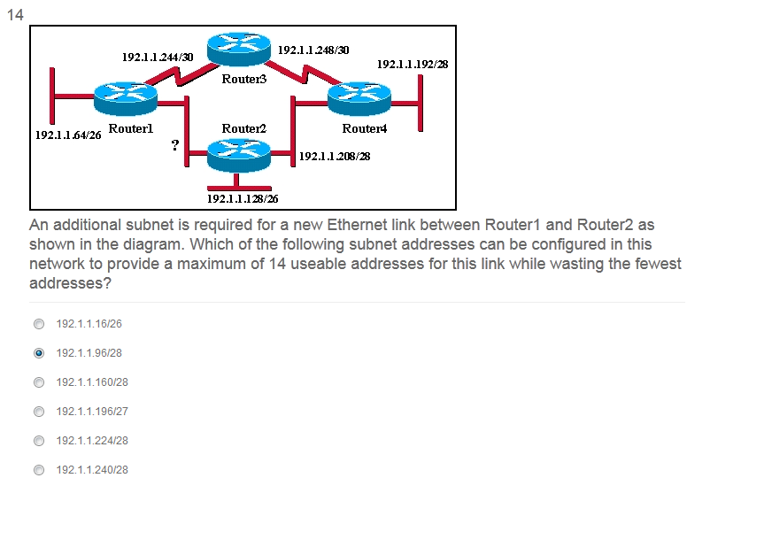

**16**.

[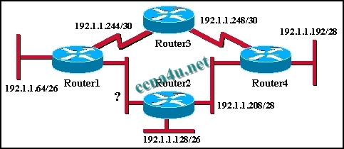](http://answers.ccna4u.net/wp-content/uploads/2011/02/1312.jpg)

**An additional subnet is required for a new Ethernet link between Router1 and Router2 as shown in the diagram. Which of the following subnet addresses can be configured in this network to provide a maximum of 14 useable addresses for this link while wasting the fewest addresses?**  
192.1.1.16/26  
192.1.1.96/28  
192.1.1.160/28  
192. 1.1.196/27  
192.1.1.224/28  
192.1.1.240/28

